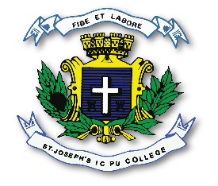
ST. JOSEPH’S INDIAN COMPOSITE PU COLLEGE
#23, Vittal Mallya Road, Bangalore – 560001.

SUBJECT: ECONOMICS (22)
II PUC
SYLLABUS FOR I TEST – 2023-24

Chapters - Micro Economics :
1. Introduction,
2. Theory of Consumer Behaviour,
3. Production and Costs.

